Rascal Concept of Operations Trade Study

Saint Louis University

Rascal

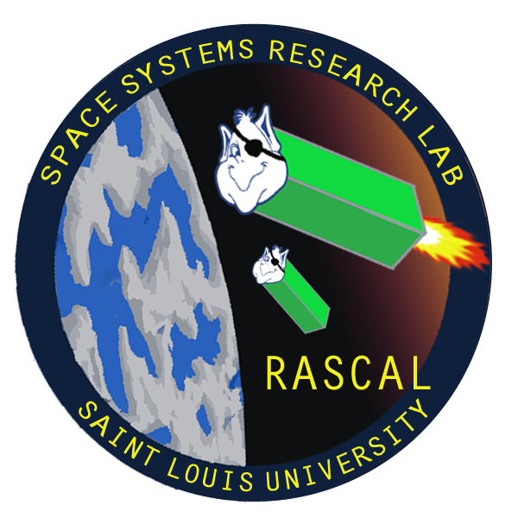

Last Updated: 3/5/14

Document No: RCL-O-CMQA3

Copper Operational

Test Plan

|  |  |  |  |
| --- | --- | --- | --- |
| **Team Member** | **Position** | **Email** | **Phone** |
| Tom Moline | Program Manager/Attitude Determination and Control Lead | [tmoline@slu.edu](mailto:tmoline@slu.edu) | 630-401-0791 |
| Nate Richard | Communications Lead | [nrichar8@slu.edu](mailto:nrichar8@slu.edu) | 608-732-7147 |
| Tyler Olson | Power Lead | [tolson6@slu.edu](mailto:tolson6@slu.edu) | 812-204-1098 |
| Bryant Gaume | Structures Lead | [gbryant1@slu.edu](mailto:gbryant1@slu.edu) | 636-448-0378 |
| Jennifer Babb | Command and Data Handling Lead | [jbabb1@slu.edu](mailto:jbabb1@slu.edu) | 636-579-6816 |

**Revisions Summary**

|  |  |  |  |  |
| --- | --- | --- | --- | --- |
| **Revision** | **Description** | **Date** | **Prepared by** | **Approved by** |
| **-** | Initial Release | 3/5/2014 | Tom Moline | Insert Name Here |
|  |  |  |  |  |
|  |  |  |  |  |
|  |  |  |  |  |
|  |  |  |  |  |
|  |  |  |  |  |

Table of Contents

1 Introduction 5

1.1. Background 5

1.2. Rascal Mission Statement and Overall Mission Architecture 5

2 Concept(s) of Operations 6

# Introduction

## Background

This document serves to outline and compare two proposed concept of operations (CONOPS) associated with the Rascal mission. Each CONOPS would successfully demonstrate Rascal’s mission statement (As discussed in Section 1.2), though each would do so in drastically different fashions, as discussed in Section 2.

## Rascal Mission Statement and Overall Mission Architecture

Rascal’s mission can be summed up as:

**The Rascal mission seeks to incrementally demonstrate the capability of a small-spacecraft in performing proximity operations, rendezvous, and inspection of both a cooperating and non-cooperating resident space object.**

Though there are many other missions attempting to demonstrate similar or greater capabilities as those outlined above (Such as Tyvak’s PONSFD, Surrey’s STraND-2, and Embry-Riddle’s ARAPAIMA), Rascal is the only mission that has taken seriously the challenges associated with conducting rendezvous and proximity operation (RPO) missions of any scale and actually integrated a realistic assessment of program capability directly into its mission design.

It is from this assessment where the “incremental” part of the mission statement comes in. As opposed to seeking out another spacecraft on the same launch or going after a decommissioned spacecraft that is already in orbit, hoping that spacecraft acquisition and checkout occurs fast enough for the mission to actually be performed, Rascal will bring with it the target it seeks to perform its mission relative to. This alleviates the many risks associated with the “initial conditions” problem of orbital analysis and planning. Instead of attempting to account for the impact of perturbation forces (mainly, aerodynamic drag, third-body influences, solar-radiation pressure) on two spacecraft released at slightly different times in slightly different locations, and hoping that these initial conditions match up in a way that allow for the mission to be quickly executed, one can eliminate all the uncertainty and not start the mission until contact has been confirmed between each mission spacecraft and the ground. This allows for a more precise understanding of both where and when the mission is actually starting, which greatly increases the odds of its ultimate success.

As such, regardless of the way in which the mission will be executed, several components of the overall mission architecture will be fixed, mainly:

* **The Target spacecraft will be brought with the Interceptor**: this removes the risk of securing permission to go and inspect either another organization’s spacecraft or a company’s rocket body (as has been done in the past), as well as that of finding an object to perform inspection of.
* **The Target and Interceptor will be conjoined up until mission commencement**: this removes the problem of “initial conditions”, giving the mission operators greater control over the mission as a whole.
* **The mission will be conducted “incrementally”**: this attests to the difficulties that past RPO missions have encountered over the course of their mission life, as well as realistically assesses the risks associated with RPO missions of any scale. An example of this would be performing the mission in steps, first inspecting a cooperating resident space object (with image processing visual aids, differential GPS, etc), and then incrementally removing the cooperating portions of the mission until enough confidence could be put into demonstrating inspection on a non-cooperating resident space object.

# Concept(s) of Operations

## General CONOPS Overview and Definitions

With the discussion in the previous section in mind, two general CONOPS can be drafted that are capable of demonstrating mission success:

* **RPO Demonstration without Docking**
* **RPO Demonstration with Docking**

The former would still demonstrate key RPO maneuvers, such as the ability to stationkeep at various distances from a resident space object, to rendezvous with said object, and to inspect said object through the use of image processing, thus warranting its launch. The latter would demonstrate all of the same maneuvers, with the added complexity of integrating a reusable docking system and the more complicated orbital mechanics related therein. Though this would allow for the ability to “pause” the mission (for example, if midterms are coming up for student operators, the target and interceptor spacecraft can be docked until some date, at which point separation can be initiated and the mission can recommence), it also adds developmental risk (greater focus being put on developing a docking mechanism, as opposed to payload or mission design), as well as mission risk (colliding at too great a speed, missing the target, damaging the imaging payload, etc).

Regardless, each mission CONOPS will rely on similar terminology and mission phases, as described below:

* **Target Spacecraft:** spacecraft about which all RPO maneuvers would be performed.
* **Interceptor Spacecraft**: spacecraft with which all RPO maneuvers would be executed.
* **Cooperative State**: target spacecraft state in which all interceptor RPO aids (such as image processing aids, differential GPS, etc) are active.
* **Pseudo-Cooperative State**: target spacecraft state in which some (but not all) interceptor RPO aids are active.
* **Uncooperative State**: target spacecraft state in which no interceptor RPO aids are active.
* **Stationkeeping**: keeping a set relative distance between the target and interceptor spacecraft while maintaining as small a relative velocity as possible.
* **Inspection Stationkeeping (ISK)**: stationkeeping within 10 meters of the target spacecraft.
* **Remote Stationkeeping (RSK)**: stationkeeping at least 100 meters away from the target spacecraft.
* **Rendezvous**: the act of reducing the relative distance between the target and interceptor spacecraft.
* **Separation**: the act of increasing the relative distance between the target and interceptor spacecraft.
* **Docking**: the act of conjoining the target and interceptor spacecraft after separation (only occurs during cooperative state).
* **Pause State**: mission state in which the target and interceptor spacecraft are docked due to mission timing constraints.
* **Uncooperative Mission Timer**: timer that is set prior to the uncooperative portions of the mission that, upon running down, forces the target spacecraft into its cooperative state.

## CONOPS One: RPO Demonstration without Docking